

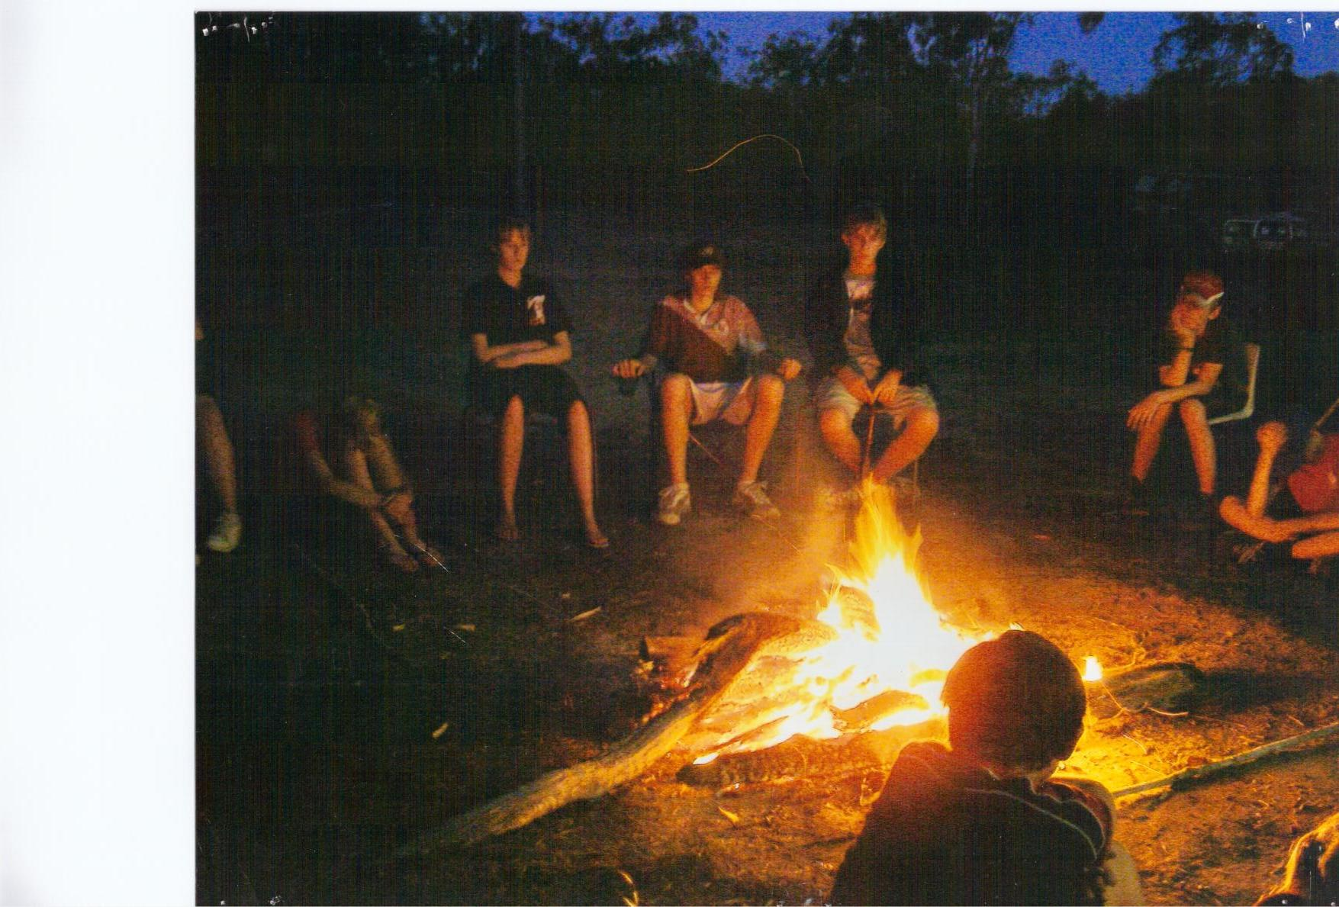
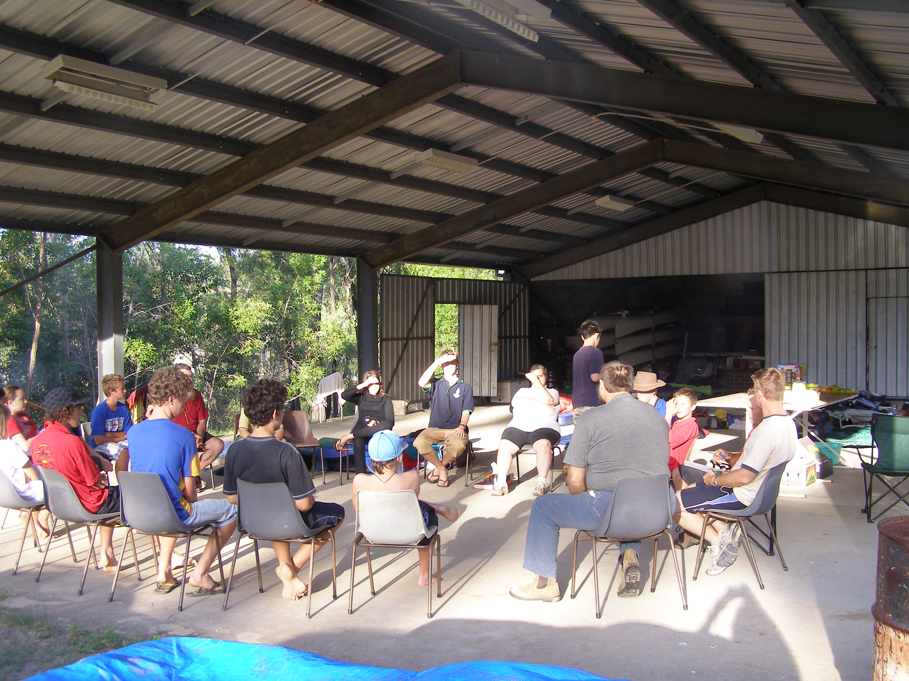
Lake Monduran Dam SDA Camp
BOOKINGS
Lake Monduran SDA Camp Secretary
Frann Hawes
345 Avondale Rd
Avondale Qld 4670
Tel/Fax: 07 41561486 / 0408018647
Email: butterflys24@bigpond.com
ABN: 90 737 679 287

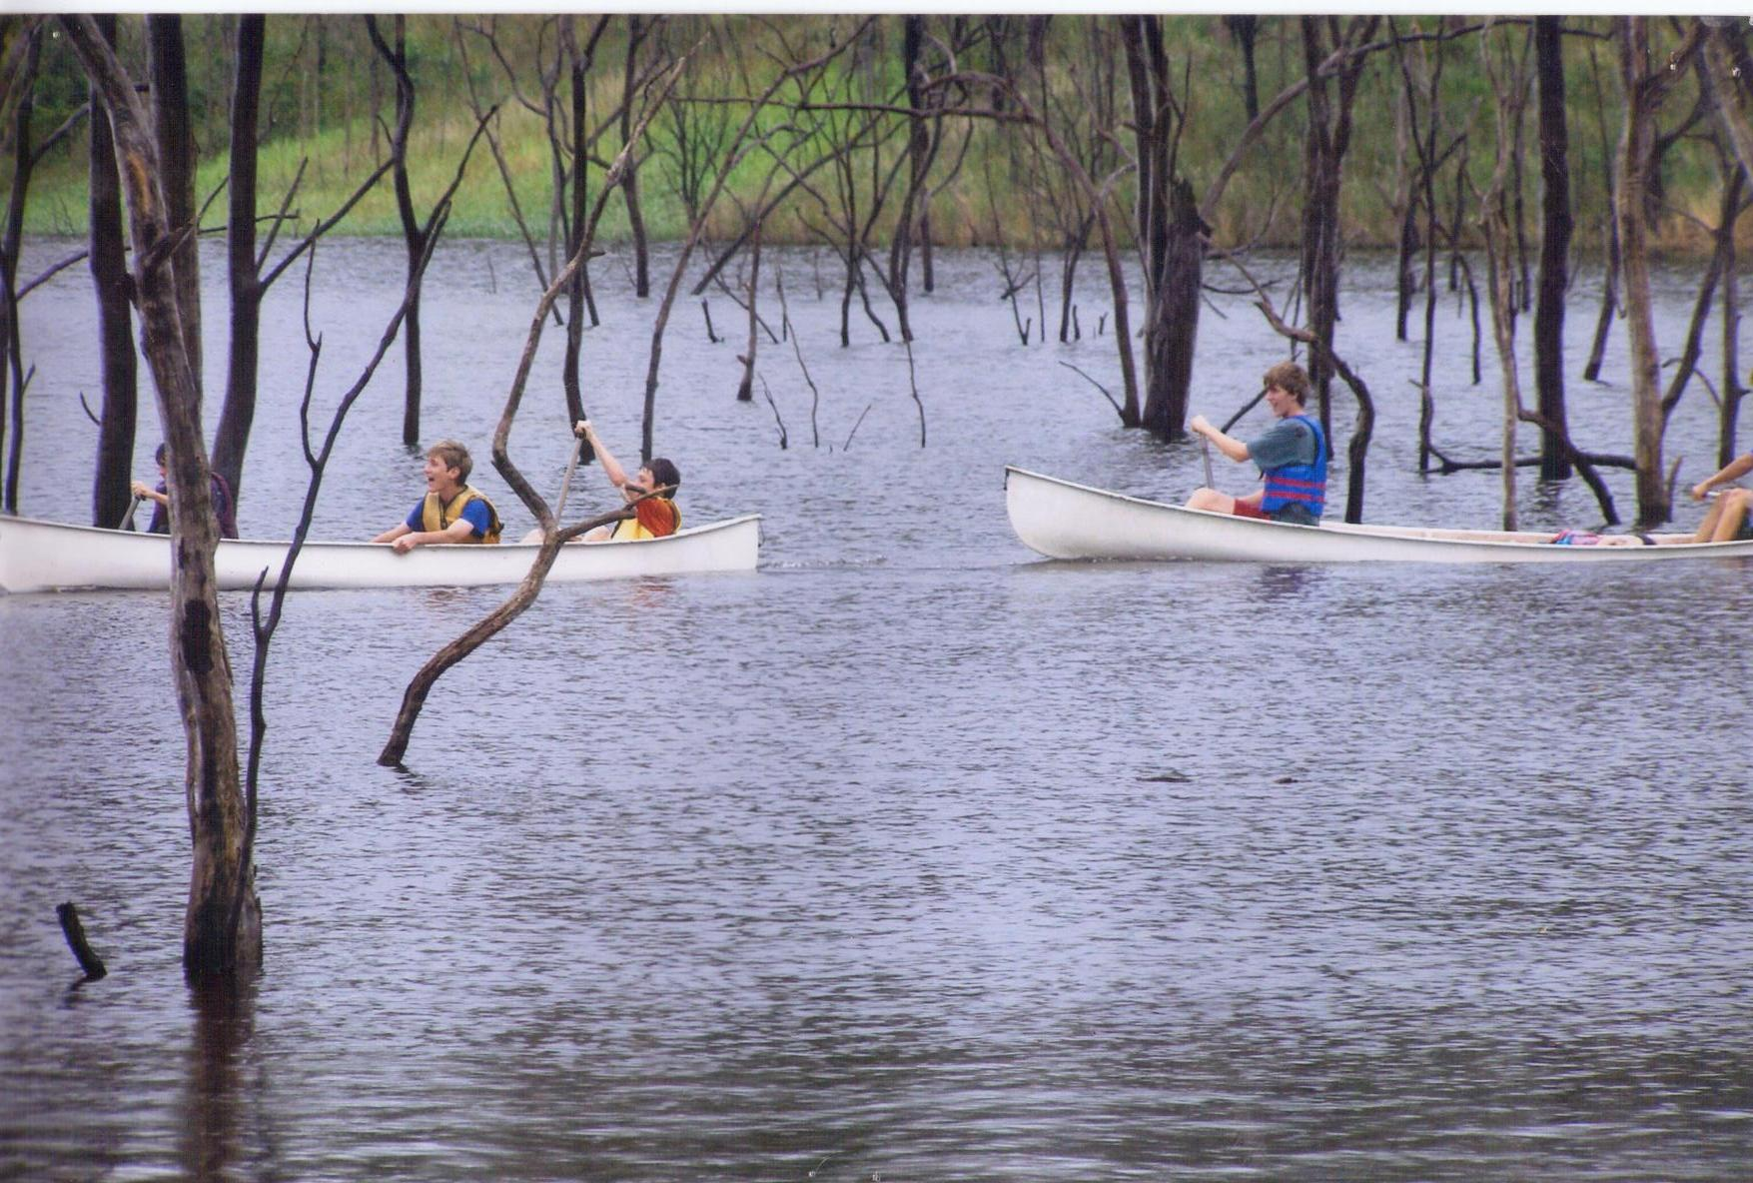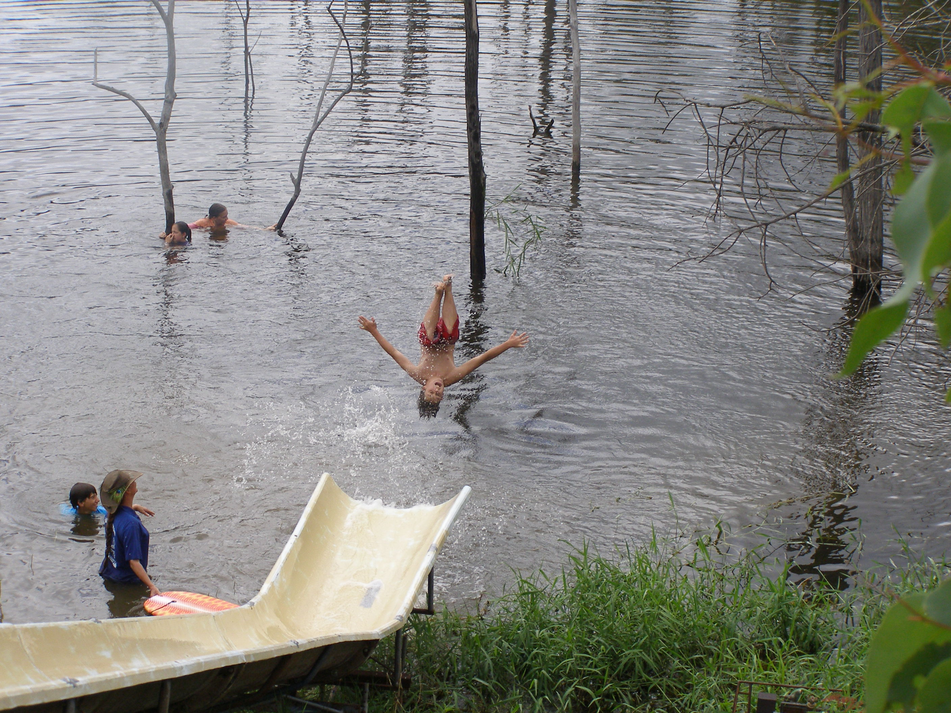
Welcome to Lake Monduran SDA Camp.
We are 22k north of Gin Gin at Lake Monduran Dam/Fred Haigh Dam. Lake Monduran SDA camp is set in natural bush land surrounded with cattle country and water frontage. You can make as much noise as you like.
We have Electricty, wood fired hot water service, conference shed, hot and cold showers male and female, flushing toilets male and female, large oval with lighting, unregistered kitchen, trestle tables, long seats and chairs. We have a two gas Bar-B-Q’s which can be used out side. Campfire site, waterslide, water pontoon, canoes (at extra cost) and swimming area, which has been cleaned out of all the timber in the water for safe swimming and easy access for boats and canoes. Great place for skiing and jet-skiing. There is about 10 acres of camp grounds maintained for camping. Water access on foot and 4wd. There are other boat ramps along Monduran road near campgrounds.
The conference shed is a basketball court size with one end closed in. We have a 2X3 meter screen for lectures or movies. Plenty of power out lets for all the electrical equipment that you may need which you will need to bring. Campgrounds have plenty of lighting around toilets, Conference Shed and Oval and some lighting for camping. Campers will need torches. The campgrounds can cater a 150 to 200 people.
There is a kiosk 4ks down the road, which has some food supplies, boat hire, fishing permits for over 18 years, ice etc. Walking tracks around local area including Dam wall and BMX riding. Live Fish display at Kiosk.
Campers will need to bring own tents or caravan and food.
Full Mobile reception.
There is plenty of drinking water on site.
Hiring to groups with own Public Liability Insurance.
PRICE not including GST : $11 per person per night.
(not including canoe hirer)

God Bless

Lake Monduran SDA Camp Secretary
Frann Hawes
345 Avondale Rd
Avondale 4670
Ph/Fax 07 41561486
E-mail: butterflys24@bigpond.com
ABN: 90 737 679 287

